Calibration of the Near-Infrared Channels of a PREDE-POM Sun Photometer Using Standard and Modified Langley Plots
HARMONIA COST Action – Virtual Mobility
Abstract
We calibrated the 2 near infrared (NIR) wavelengths ( 1627 and 2200 nm), of a PREDE-POM02 sun photometer located in Takayama Observatory, Japan (36.056° N, 140.125° E; altitude 1.4 km) using the standard Langley plot techniques on three selected clear-sky days in early 2025. For these two channels water vapor absorption has been taken into account (Uchiyama et al., 2018). The standard Langley was also applied to the visible and shortwave-infrared channels (340–1020 nm) producing excellent linear fits (R² > 0.93), while the NIR channels showed larger scatter (R² = 0.50–0.81) probably due to lower signal-to-noise and stronger atmospheric variability. The retrieved V₀ values are internally consistent across the selected calibration days, showing day-to-day variations of approximately 8% at 1627 nm and 6% at 2200 nm.. Our results confirm that on-site NIR calibration is feasible, though improved water vapour data and more sampling days are needed to reduce uncertainty. The work contributes directly to the objectives of the SKYNET network and its European sub-network, ESR, by extending harmonised aerosol products beyond 1020 nm.
1. Introduction
1.1 The SKYNET network and its objectives
SKYNET is a ground-based radiation observation network dedicated to aerosol–cloud–solar radiation interaction research. Its primary objectives are to quantitatively evaluate long-term variations of aerosol and cloud properties, to understand their effects on the atmospheric radiation reaching the surface, and to assess their role in climate through aerosol–cloud–solar interaction. Validation of satellite observations from JAXA, ESA, and NASA, as well as climate model simulations and data assimilation, also fall within the scope of SKYNET activities.
SKYNET is organized into seven regional sub-networks, each contributing to the operation and maintenance of the associated instrumentation. Raw data are transferred from each Regional SKYNET Data Center (RSDC) to the International SKYNET Data Center (ISDC), which produces standard products on aerosol optical properties using algorithms approved by the International Committee. The European SKYNET Radiometers network (ESR) is one of these regional sub-networks, led by the Institute of Atmospheric Sciences and Climate (ISAC) of the Italian National Research Council (CNR) and the University of Valencia. ESR maintains a regional data center in Italy and Spain and is dedicated to the development of new products.
1.2 The near-infrared gap in SKYNET products
SKYNET has long provided harmonized aerosol optical depth (AOD) up to 1020 nm. The near-infrared (NIR) channels at 1627 and 2200 nm, however, have remained underexploited because their calibration is more difficult. Extending harmonized aerosol products to longer wavelengths is a key objective of HARMONIA Working Group 2, and it also aligns with SKYNET's broader goal of improving aerosol characterization for climate studies.
1.3 Objectives of this virtual mobility
In this virtual mobility, we set out to calibrate the NIR channels of a PREDE-POM sun photometer using the standard Langley plot and a correction for the precipitable water vapour (PWV) content. We also calibrated the visible and shortwave-infrared channels for completeness. The goal was to quantify $V_{0}$and its uncertainty, assess repeatability across days, and evaluate whether on-site calibration can be performed without moving the instrument.
2. Data and Methods
2.1 Instrument and data
We used direct-beam irradiance measurements from a PREDE-POM sun photometer on three clear-sky days: 18 January, 15 February, and 25 February 2025. The wavelengths analyzed were 340, 400, 500, 675, 870, 1020, 1627, and 2200 nm Takayama Observatory, Japan (36.056° N, 140.125° E; altitude 1.4 km)
2.2 file validation before calibration
Before running any Langley fit, we followed a fixed sequence of checks. First, we inspected the raw sun photometer file, containing sun direct irradiance measurements, for completeness, timestamp consistency, and correct header information. This ensures that the measurement series is intact and that no data are missing or corrupted. Second, we checked the dt4 file, containing sky radiances retrieved by the Skyrad_MRI model ( Kudo et al., 2021) from the almucantar measurements to confirm the specific measurement used, verify the solar geometry, and ensure the sky-radiance values are correctly formatted. Because the retrieved radiances are also cloud screened, the cross check of direct measurements and dt4 output, allowed to select days with clear sky . Only after both checks passed did we run the Langley equation on the screened data. This order matters because the dt4 file provides the direct-beam and sky-radiance inputs that feed the smoothness check and the retrieval; if the sun file or dat file is inconsistent, the dt4 file may inherit that inconsistency, and any subsequent Langley fit will be biased.
2.3 Langley plot technique
For non-absorbing channels, the standard Langley method follows the Beer–Lambert–Bouguer law:
$$ln⁡\left(V\right)=ln⁡\left(V_{0}\right)-m_{0}τ_{\text{total}}$$where $V$is the measured signal, $V_{0}$the extraterrestrial constant, $m_{0}$the air mass, and $τ_{\text{total}}$the total optical depth. For the NIR channels, water vapor absorption is significant. We therefore constructed a modified Langley plot, following the approach of Uchiyama et al. (2018):
$$Y=ln⁡\left(V\right)+m_{0}τ_{\text{PWV}}=ln⁡\left(V_{0}\right)-m_{0}\left(τ_{\text{aer}}+τ_{\text{Rayleigh}}\right)$$Here $τ_{\text{PWV}}$is the water vapor optical depth, computed from PWV using fixed coefficients: $4.2×{10}^{-5}$at 1627 nm and $1.9×{10}^{-5}$at 2200 nm.
the water vapor optical depth τ__{PWV} was computed using the SKYRAD_MRI simulation code (Kudo et al., 2021), which was run with a climatological precipitable water vapor (PWV) content representative of the Takayama site for the measurement season. The code provided the spectral water vapor optical depth at 1627 and 2200 nm, which was then used to construct the modified Langley variable Y using a climatological wv content. The intercept of $Y$versus $m_{0}$gives $ln⁡\left(V_{0}\right)$, and the slope gives the negative of the aerosol-plus-Rayleigh optical depth.
2.4 Screening and outlier removal
We restricted the air mass range to 2.0 ≤ m₀ ≤ 5.0. An initial Langley regression was performed using all measurements within this range. If the root mean square deviation (RMSD) exceeded 0.006, the point with the largest residual was removed and the regression was repeated. This iterative screening procedure continued until the RMSD threshold was satisfied. The number of fitting cycles required to obtain the final solution is reported in Table 1 under the column "iter". In addition, we performed a direct-beam smoothness check at 675 nm to identify periods of unstable atmospheric conditions; flagged points were excluded from the Langley analysis. The 675 nm wavelength was selected because it is largely free from strong gaseous absorption and is less affected by Rayleigh scattering than the shorter wavelengths, making it a reliable indicator of atmospheric stability during Langley calibration. The processing followed the standard methodology implemented in ESR.pack for PREDE-POM instruments.
3. Results
3.1 Fit quality
The visible and shortwave-infrared channels behaved as expected. At 340, 400, and 500 nm, the fits were excellent (R² > 0.998, RMSD < 0.013). The 675, 870, and 1020 nm channels also produced good linearity (R² = 0.93–0.99).
The NIR channels were more challenging. At 1627 nm, R² ranged from 0.50 to 0.71; at 2200 nm, from 0.60 to 0.81. The larger scatter could be related to the lower signal-to-noise ratio at these wavelengths and to the consideration of a climatological PW value rather than an actual measurement
3.2 Langley Plots: Summary and Discussion
3.2 Visible and shortwave-infrared channels (340–1020 nm)
Figures 1–6, present the Langley plots for 340, 400, 500, 675, 870, and 1020 nm. The quantitative fit statistics in Table 1 match the visual impression from these figures.
At 340 nm (Figure 1), the individual-day fits are excellent ($R^{2}>0.9998$), but the combined plot shows clear separation between the three dates. The table confirms this: $V_{0}$varies from $4.06×{10}^{-6}$(18 Jan) to $6.34×{10}^{-6}$(25 Feb), a spread of more than 50%. The slope also changes from 0.612 to 0.563. This is consistent with the strong sensitivity of the 340 nm channel to Rayleigh scattering, which depends on pressure and temperature, and to day-to-day atmospheric variability. Outlier removal was aggressive: 12 points reduced to 3 on 18 Jan, 11 to 5 on 15 Feb, and 9 to 4 on 25 Feb. This improves the fit but reduces the robustness of the intercept.
At 400 nm (Figure 2) and 500 nm (Figure 3), the fits remain excellent ($R^{2}>0.998$ at 400 nm, $R^{2}>0.9986$at 500 nm), and the three dates converge more closely in the combined plots. The $V_{0}$values are more stable: at 500 nm they range from $2.23×{10}^{-4}$to $2.54×{10}^{-4}$, a spread of about 13%. The 25 Feb data required no outlier removal at 400 or 500 nm, suggesting stable conditions on that day.
At 675 nm (Figure 4), the fits are good ($R^{2}=0.979$–0.995) and the combined plot shows the three dates almost overlapping. $V_{0}$is tightly constrained: $3.25×{10}^{-4}$to $3.56×{10}^{-4}$. No outlier removal was needed on any date (Ninit = Nfin). This indicates a stable instrument response and a well-defined slope.
At 870 nm (Figure 5), linearity is moderate ($R^{2}=0.950$–0.974). The slopes are small (0.0128–0.0173), and $V_{0}$ranges from $2.37×{10}^{-4}$to $2.60×{10}^{-4}$. The combined plot shows some scatter but no large offsets. No outliers were removed.
At 1020 nm (Figure 6), linearity is good but slightly lower than at 675 or 870 nm ($R^{2}=0.935$–0.944). The slopes are very small (0.0070–0.0105), so the intercept is less well constrained. $V_{0}$ranges from $2.17×{10}^{-4}$to $2.39×{10}^{-4}$. No outlier removal was needed, but the lower $R^{2}$indicates that the signal-to-noise ratio and residual water-vapour absorption are beginning to affect the fit.
3.3 Near-infrared channels (1627 and 2200 nm)
Figures 7 and 8 show the Langley plots for 1627 and 2200 nm. These are the most challenging channels, and Table 1 quantifies the difficulty.
At 1627 nm (Figure 7), $R^{2}$ranges from 0.50 to 0.71. The slopes are extremely shallow (0.0021–0.0040), meaning that $ln⁡\left(V\right)$changes very little with air mass. As a result, the intercept is poorly constrained. No outliers were removed on any date (Ninit = Nfin), yet the scatter remains large. This shows that the problem is not a few outliers but intrinsic noise: low signal-to-noise, low aerosol optical depth, and variable water-vapour absorption. The derived $V_{0}$values are $1.45×{10}^{-4}$(18 Jan), $1.34×{10}^{-4}$(15 Feb), and $1.42×{10}^{-4}$(25 Feb), a day-to-day variation of about 8%.
At 2200 nm (Figure 8), the situation is similar. $R^{2}$ranges from 0.60 to 0.81. Slopes are again very small (0.0021–0.0050). $V_{0}$values are $8.77×{10}^{-5}$(18 Jan), $8.25×{10}^{-5}$(15 Feb), and $8.78×{10}^{-5}$(25 Feb), a variation of about 6%. The combined plot shows both scatter within each date and offsets between dates. As with 1627 nm, no outlier removal was applied, confirming that the scatter is inherent to the measurement and atmospheric conditions.
These findings are consistent with the general difficulty of NIR calibration noted by Uchiyama et al. (2018), who found that the 1627 and 2200 nm channels have gas absorption below 1%. The day-to-day scatter in our NIR $V_{0}$values (about 8% at 1627 nm and 6% at 2200 nm) confirms that single-day calibrations are not reliable.
Table 1. Langley fit summary for all wavelengths and dates.
WL_nm | Da | te | Ninit | Nfin | ln(V0) | V0 | slope | RMSD | R^2 | iter | m0_min | m0_max
340 | 18 | Jan | 12 | 3 | -12.414 | 0.0000041 | 0.612 | 0.0094 | 0.9998 | 3 | 2.017 | 4.471
340 | 15 | Feb | 11 | 5 | -12.191 | 0.0000051 | 0.586 | 0.0127 | 0.9997 | 2 | 2.029 | 4.878
340 | 25 | Feb | 9 | 4 | -11.969 | 0.0000063 | 0.563 | 0.0043 | 0.9999 | 2 | 2.110 | 4.438
400 | 18 | Jan | 12 | 3 | -9.433 | 0.0000801 | 0.311 | 0.0037 | 0.9999 | 3 | 2.017 | 4.471
400 | 15 | Feb | 11 | 5 | -9.380 | 0.0000844 | 0.302 | 0.0075 | 0.9996 | 2 | 2.029 | 4.878
400 | 25 | Feb | 9 | 9 | -9.213 | 0.0000998 | 0.286 | 0.0057 | 0.9993 | 1 | 2.110 | 4.438
500 | 18 | Jan | 12 | 5 | -8.360 | 0.0002339 | 0.127 | 0.0049 | 0.9987 | 2 | 2.017 | 4.471
500 | 15 | Feb | 11 | 5 | -8.409 | 0.0002229 | 0.127 | 0.0049 | 0.9990 | 2 | 2.029 | 4.878
500 | 25 | Feb | 9 | 9 | -8.278 | 0.0002541 | 0.115 | 0.0026 | 0.9991 | 1 | 2.110 | 4.438
675 | 18 | Jan | 12 | 12 | -7.951 | 0.0003522 | 0.039 | 0.0043 | 0.9789 | 1 | 2.017 | 4.471
675 | 15 | Feb | 11 | 11 | -8.031 | 0.0003251 | 0.041 | 0.0043 | 0.9856 | 1 | 2.029 | 4.878
675 | 25 | Feb | 9 | 9 | -7.940 | 0.0003562 | 0.036 | 0.0020 | 0.9946 | 1 | 2.110 | 4.438
870 | 18 | Jan | 12 | 12 | -8.253 | 0.0002604 | 0.015 | 0.0027 | 0.9500 | 1 | 2.017 | 4.471
870 | 15 | Feb | 11 | 11 | -8.347 | 0.0002371 | 0.017 | 0.0034 | 0.9518 | 1 | 2.029 | 4.878
870 | 25 | Feb | 9 | 9 | -8.262 | 0.0002581 | 0.013 | 0.0016 | 0.9741 | 1 | 2.110 | 4.438
1020 | 18 | Jan | 12 | 12 | -8.341 | 0.0002385 | 0.008 | 0.0016 | 0.9359 | 1 | 2.017 | 4.471
1020 | 15 | Feb | 11 | 11 | -8.434 | 0.0002174 | 0.011 | 0.0022 | 0.9443 | 1 | 2.029 | 4.878
1020 | 25 | Feb | 9 | 9 | -8.356 | 0.0002351 | 0.007 | 0.0014 | 0.9349 | 1 | 2.110 | 4.438
1627 | 18 | Jan | 12 | 12 | -8.839 | 0.0001450 | 0.002 | 0.0014 | 0.5627 | 1 | 2.017 | 4.471
1627 | 15 | Feb | 11 | 11 | -8.919 | 0.0001339 | 0.004 | 0.0022 | 0.7130 | 1 | 2.029 | 4.878
1627 | 25 | Feb | 9 | 9 | -8.859 | 0.0001422 | 0.003 | 0.0019 | 0.5005 | 1 | 2.110 | 4.438
2200 | 18 | Jan | 12 | 12 | -9.342 | 0.0000877 | 0.004 | 0.0014 | 0.7914 | 1 | 2.017 | 4.471
2200 | 15 | Feb | 11 | 11 | -9.403 | 0.0000825 | 0.005 | 0.0021 | 0.8056 | 1 | 2.029 | 4.878
2200 | 25 | Feb | 9 | 9 | -9.341 | 0.0000878 | 0.002 | 0.0013 | 0.6023 | 1 | 2.110 | 4.438

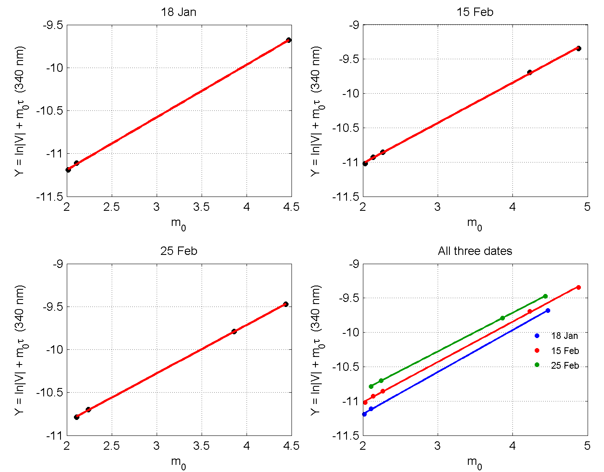
Figure 1: Langley plots at 340 nm (18 Jan, 15 Feb, 25 Feb, and combined)

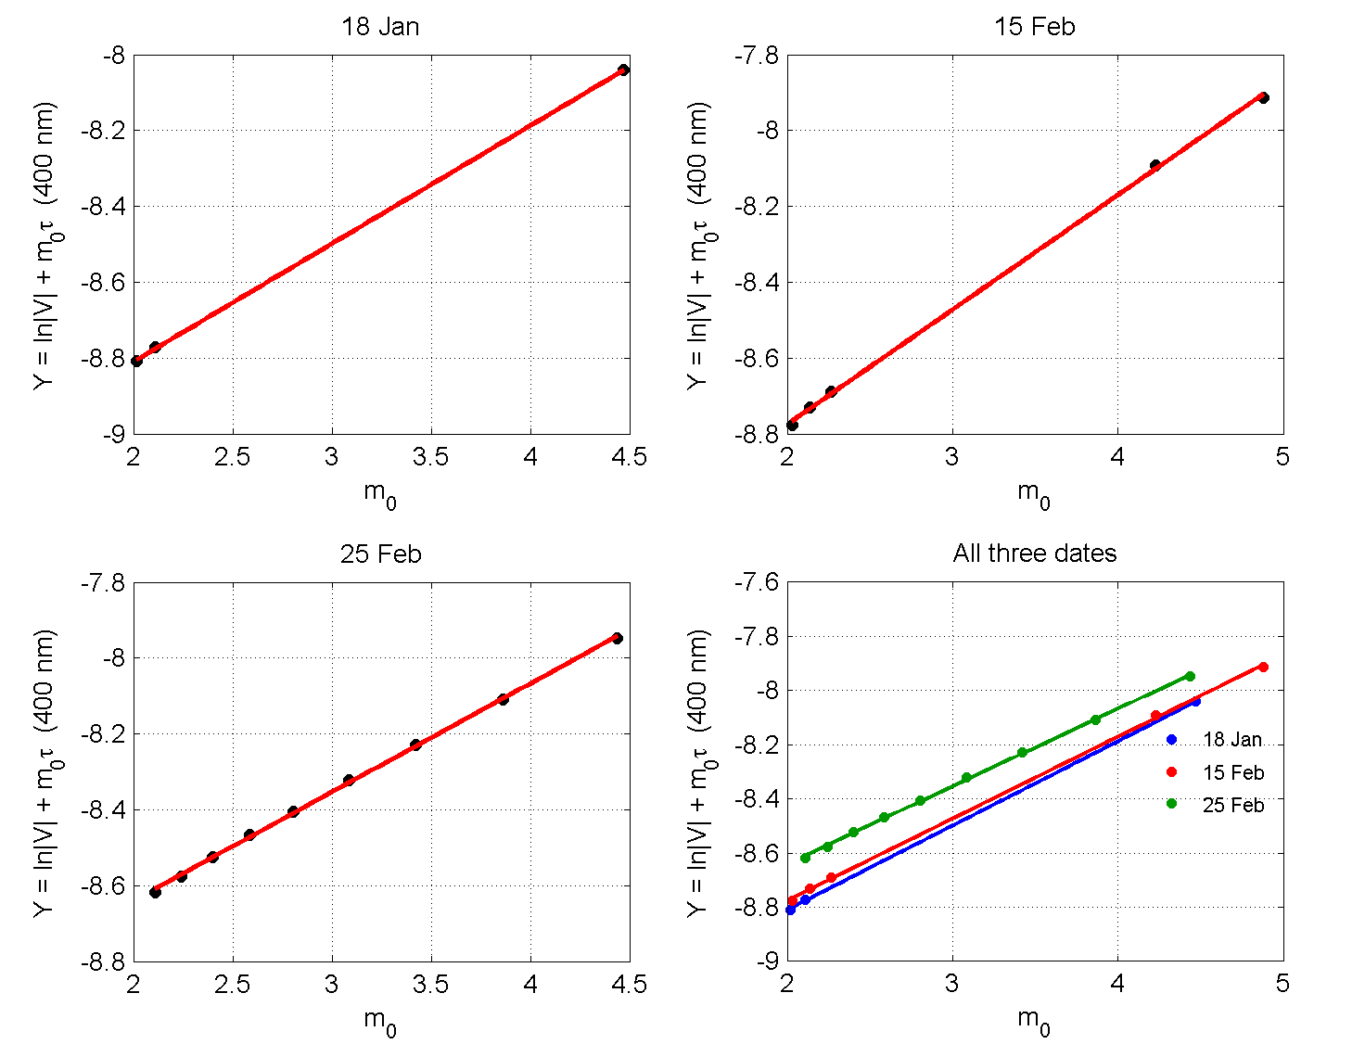
Figure 2: Langley plots at 400 nm (18 Jan, 15 Feb, 25 Feb, and combined)
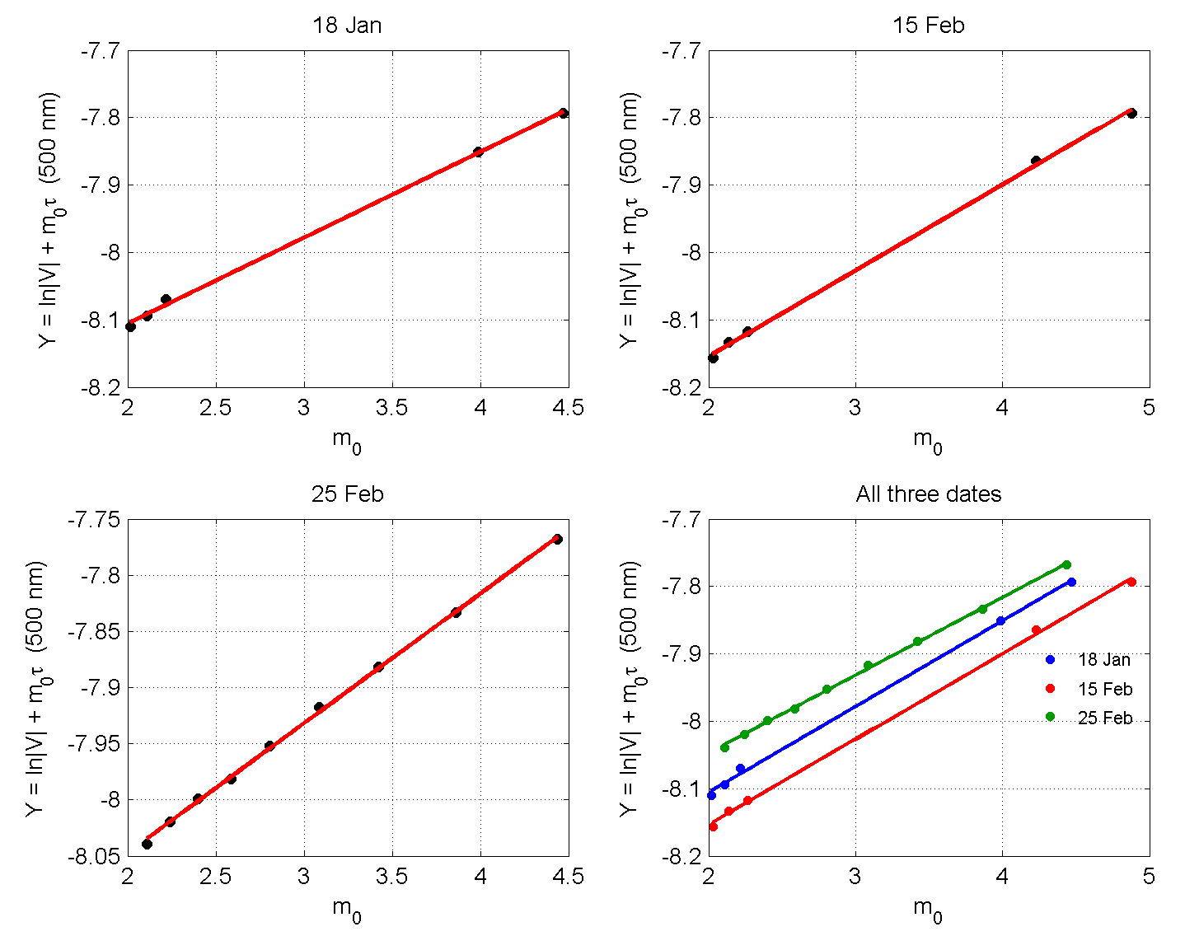
Figure 3: Langley plots at 500 nm (18 Jan, 15 Feb, 25 Feb, and combined)

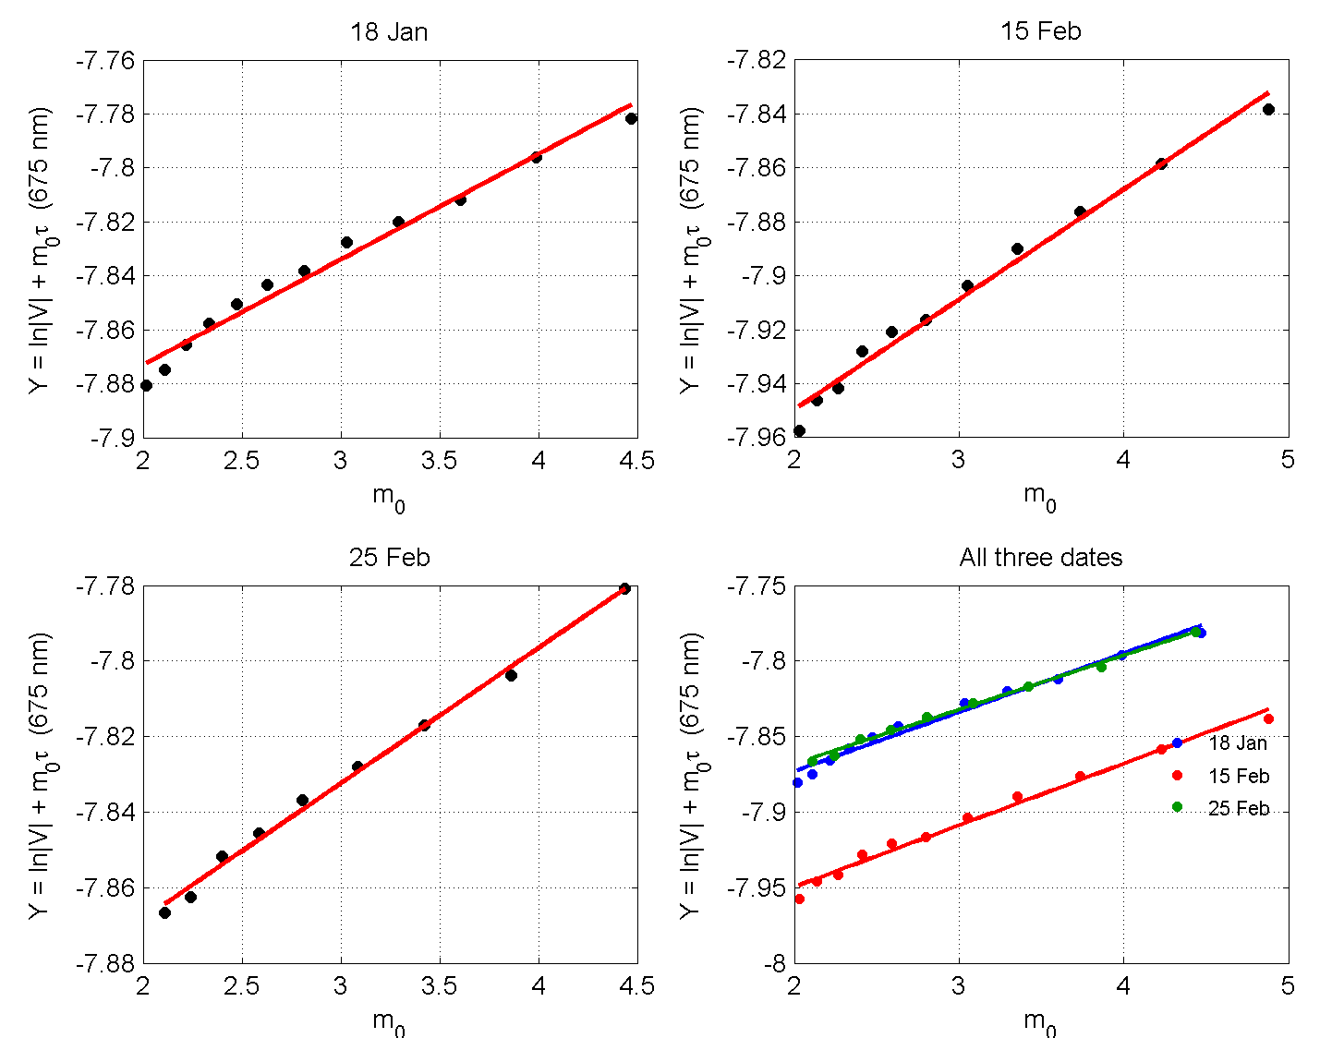
Figure 4: Langley plots at 675 nm (18 Jan, 15 Feb, 25 Feb, and combined)
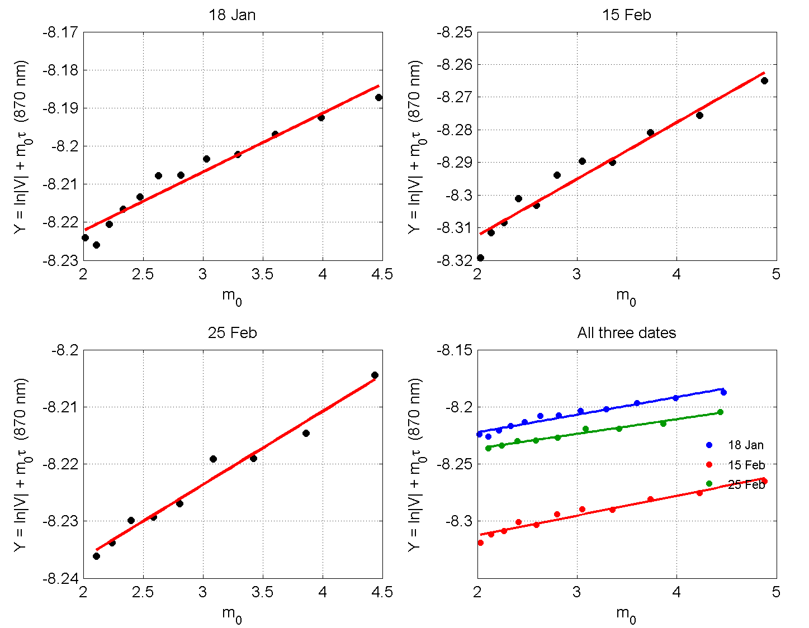
Figure 5: Langley plots at 870 nm (18 Jan, 15 Feb, 25 Feb, and combined)

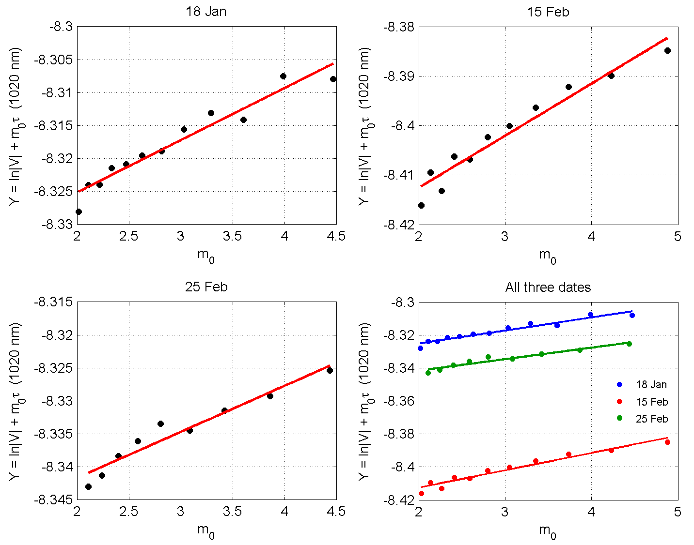
Figure 6: Langley plots at 1020 nm (18 Jan, 15 Feb, 25 Feb, and combined)

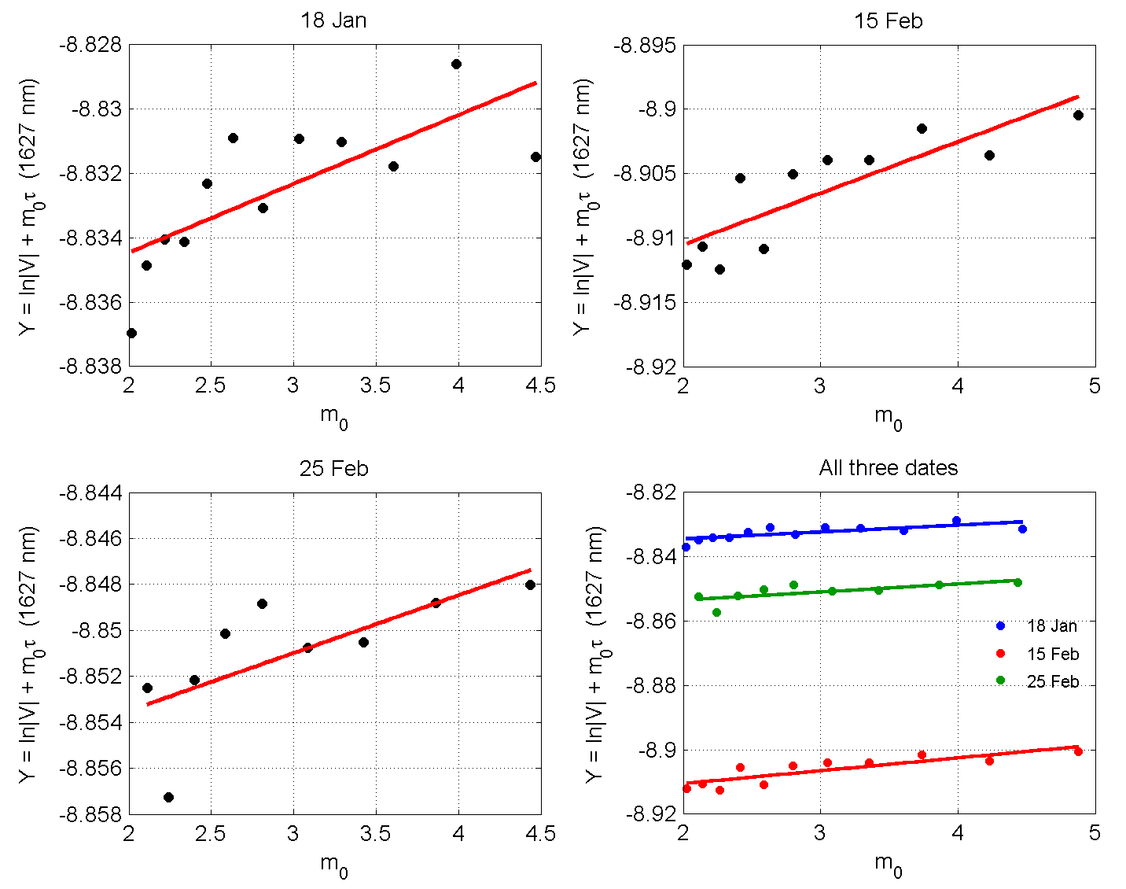
Figure 7: Langley plots at 1627 nm (18 Jan, 15 Feb, 25 Feb, and combined)

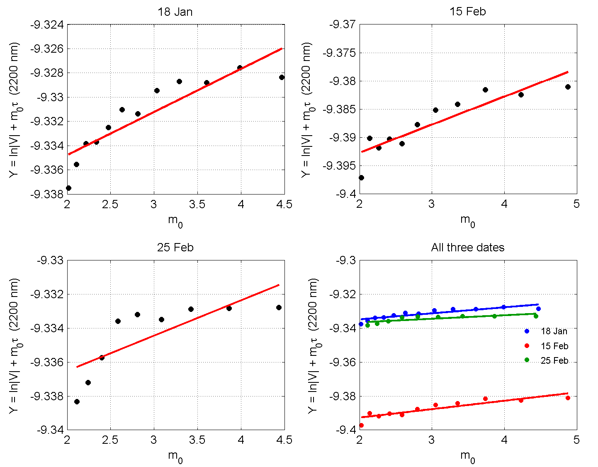
Figure 8: Langley plots at 2200 nm (18 Jan, 15 Feb, 25 Feb, and combined)

These findings obtained with a standard Langley method are however consistent with previous work performed using a modified version of Lanley method (Uchiyama et al. (2018)), not set up during this VM. He reported that the modified Langley method for the 1225, 1627, and 2200 nm channels required careful selection of dry conditions and ancillary PWV data, and that uncertainties remained higher than for visible channels. They found that the modified Langley method gave V₀ values differing by only 0.8%, 0.4%, and 0.1% from the standard Langley method at 1225, 1627, and 2200 nm, respectively, but the scatter was still larger. The day-to-day scatter in our NIR V₀ values (about 8% at 1627 nm and 6% at 2200 nm) confirms that single-day calibrations are not reliable. For operational use within SKYNET and the ESR network, NIR calibration should be based on multiple days, real-time PWV data, and advanced methods such as SKYMAP (Momoi et al., 2020) or the improved Langley method (Nakajima et al., 1996). This would allow harmonized aerosol products to be extended beyond 1020 nm, directly supporting HARMONIA Working Group 2 and the broader SKYNET objective of improving aerosol–cloud–radiation research.
3.3 Derived $V_{0}$for NIR channels
Table 2 summarizes the NIR results. The day-to-day variation in $V_{0}$is noticeable—about 8% at 1627 nm and 6% at 2200 nm—which points to either instrumental drift or residual atmospheric effects.
Table 2. Derived $V_{0}$for the NIR channels.
Date | $V_{0}$at 1627 nm | $V_{0}$at 2200 nm
18 Jan | $$1.450×{10}^{-4}$$ | $$8.767×{10}^{-5}$$
15 Feb | $$1.339×{10}^{-4}$$ | $$8.251×{10}^{-5}$$
25 Feb | $$1.422×{10}^{-4}$$ | $$8.778×{10}^{-5}$$

3.5 Direct-beam smoothness check
Figures 9–11 show the direct-beam irradiance at 675 nm for the three dates. These plots were used to assess data quality and identify periods of stable atmospheric conditions.
Figure 9. Direct-beam smoothness check at 675 nm for 18 January 2025. The irradiance follows a smooth diurnal curve, with a sharp drop after ~7 hours local time. No points were flagged as outliers, indicating stable conditions during the morning.
Figure 10. Direct-beam smoothness check at 675 nm for 15 February 2025. Several points are flagged (red dots) around 7–8 hours local time, corresponding to a sudden drop in irradiance. These points were excluded from the Langley analysis.
Figure 11. Direct-beam smoothness check at 675 nm for 25 February 2025. One point is flagged at the end of the day (~22 hours local time). The rest of the curve is smooth, indicating stable conditions for most of the measurement period.
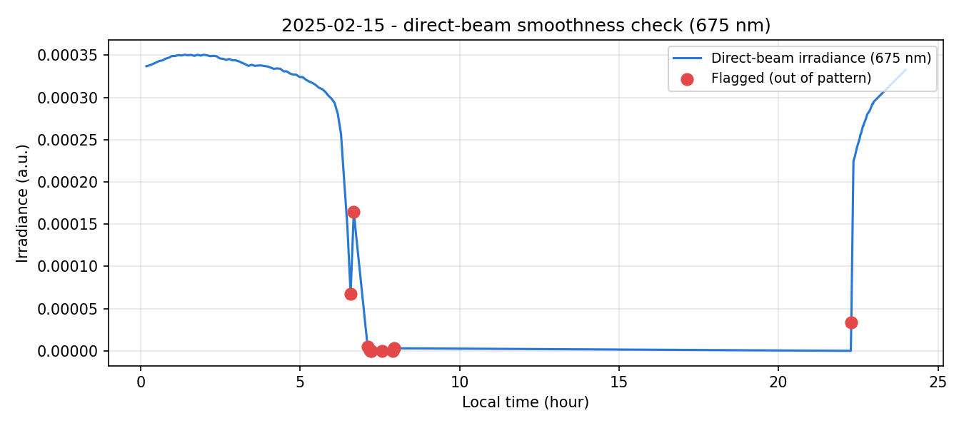
Figure 9: Direct-beam smoothness check at 675 nm for 18 Jan 2025

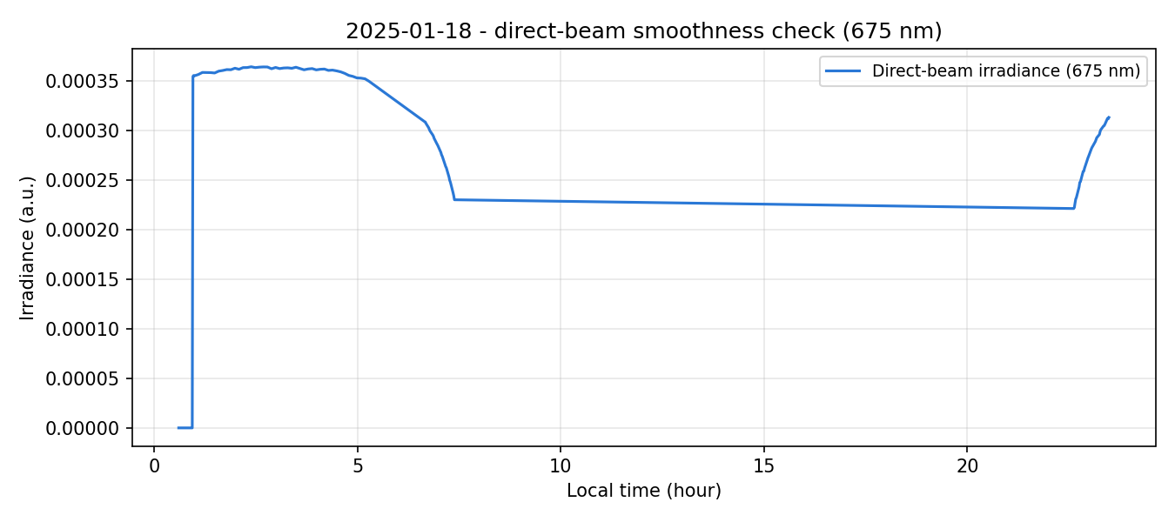
Figure 10 : Direct-beam smoothness check at 675 nm for 15 Feb 2025

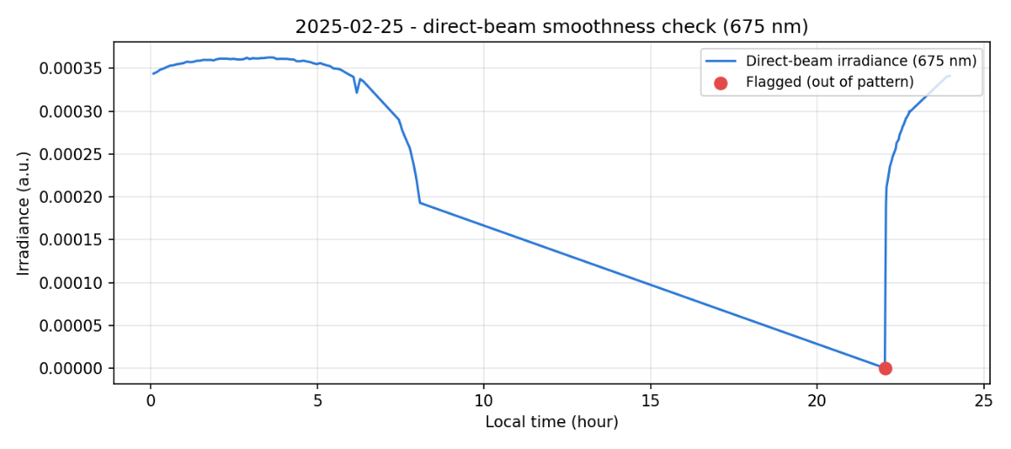
Figure 11 : Direct-beam smoothness check at 675 nm for 25Feb 2025

3.6 Interpreting the combined Langley plots
The combined plots are instructive. For the visible channels, the three dates show distinct offsets at 340 nm as shown in Figure 1 (blue, red, and green separated), converge at 400–500 nm, and almost overlap at 675 nm as shown Figure 4. This suggests that the instrument response is stable, and that the offsets at 340 nm reflect day-to-day differences in atmospheric conditions or the larger sensitivity of the 340 nm channel to Rayleigh scattering, which depends on pressure and temperature. At 675 nm, the overlap indicates that the calibration is consistent across days.
In contrast, the NIR combined plots show not only offsets but also large scatter within each date. This means that the three days do not give a single consistent $V_{0}$. Each day’s intercept is affected by different PWV and by noise. The scatter is not just random; it reflects the fact that the modified Langley correction is imperfect and the signal is weak.
3.7 Implications for SKYNET and HARMONIA
The results confirm that standard Langley calibration is robust for the visible and SWIR channels. For the NIR channels, a modified approach is required. For operational use within SKYNET and the ESR network, NIR calibration should be based on multiple days, real-time PWV data, and advanced methods such as SKYMAP (on-site self-calibration methods (Momoi et al., 2020 ) or the improved Langley method. This would allow harmonized aerosol products to be extended beyond 1020 nm, directly supporting HARMONIA Working Group 2 and the broader SKYNET objective of improving aerosol–cloud–radiation research.

References
- Kudo, R., Diémoz, H., Estellés, V., Campanelli, M., Momoi, M., Marenco, F., Ryder, C. L., Ijima, O., Uchiyama, A., Nakashima, K., Yamazaki, A., Nagasawa, R., Ohkawara, N., & Ishida, H. (2021). Optimal use of the Prede POM sky radiometer for aerosol, water vapor, and ozone retrievals. Atmospheric Measurement Techniques, 14(5), 3395–3426. https://doi.org/10.5194/amt-14-3395-2021
- Momoi, M., Kudo, R., Aoki, K., Miura, K., & Nakajima, T. (2020). Development of on-site self-calibration and retrieval methods for sky-radiometer observations of precipitable water vapor. Atmospheric Measurement Techniques, 13(5), 2635–2658. https://doi.org/10.5194/amt-13-2635-2020
- Nakajima, T., Hayasaka, T., Higurashi, A., Hashida, G., Moharram-Nejad, N., Najafi, Y., & Valavi, H. (1996). Aerosol optical properties in the Iranian region obtained by ground-based solar radiation measurements in the summer of 1991. Journal of Applied Meteorology, 35(8), 1265–1278. https://doi.org/10.1175/1520-0450(1996)035<1265:AOPITI>2.0.CO;2
- Uchiyama, A., Matsunaga, T., & Yamazaki, A. (2018). The instrument constant of sky radiometers (POM-02) – Part 1: Calibration constant. Atmospheric Measurement Techniques, 11(9), 5363–5386. https://doi.org/10.5194/amt-11-5363-2018
- Nakajima, T., Campanelli, M., Che, H., Estellés, V., Irie, H., Kim, S.-W., et al. (2020). An overview of and issues with sky radiometer technology and SKYNET. Atmospheric Measurement Techniques, 13, 4195–4218.
- HARMONIA COST Action CA21119. Working Group 2: Improvement of aerosol products. https://www.cost.eu/actions/CA21119/
- SKYNET International Data Center. About SKYNET. https://www.skynet-isdc.org/aboutSKYNET.php
- EuroSkyRad (ESR). European SKYNET Radiometers network. https://www.euroskyrad.net/

